**🛍️ Project Documentation: Shopping Behavior Dataset Analysis**

**Introduction**

Every purchase a customer makes tells a story, not just about what they buy,   
but also why, when, and how they choose to buy. In today’s digital marketplace,   
where customers have endless choices, businesses that understand these stories stand out.

This project takes a deep dive into a Shopping Behavior dataset to explore those stories.   
Through interactive dashboards, we unpack customer demographics, shopping habits, and seasonal sales shifts.

The goal is simple yet powerful: to provide insights that help businesses connect better with their customers, optimize sales strategies, and build loyalty.

**Objectives**

The analysis was guided by key questions, each pointing us to the heart of customer behavior:

- Who are the customers? (gender, age, and demographics)

- What do they buy the most? (product categories and top items)

- When and how often do they shop? (seasonality and purchase frequency)

- How do they prefer to shop? (shipping modes, subscription choices, discount usage)

- What can businesses do differently to improve sales and retention?

**Data Overview**

The dataset captures different aspects of shopping behavior:

- Demographics: Age, gender, location

- Sales Data: Total sales, average order values, product categories, discount usage

- Customer Behavior: Frequency of purchases, subscription status, shipping preferences

- Feedback: Customer ratings

**Tools & Approach**

Tools Used: Microsoft Power BI and Microsoft Excel.

To bring this dataset to life, a structured process was followed:

**Data Cleaning & Preparation (Excel):**

Used Microsoft Excel (Power Query, formulas, and PivotTables) for initial data exploration, cleaning, and transformation: removed duplicates, standardized gender values, fixed data types, parsed dates, and created calculated columns.

- Leveraged PivotTables and conditional formatting to quickly surface anomalies and summary statistics before loading into Power BI.

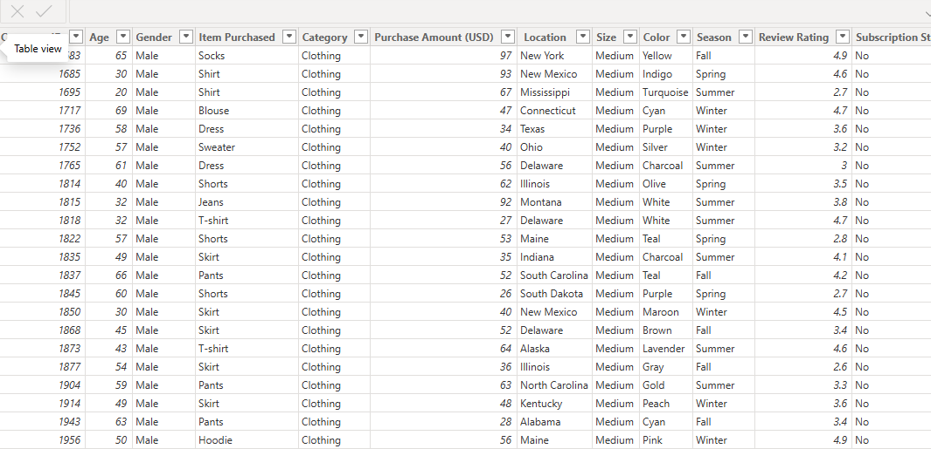

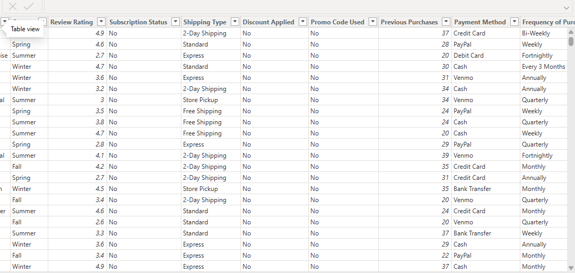

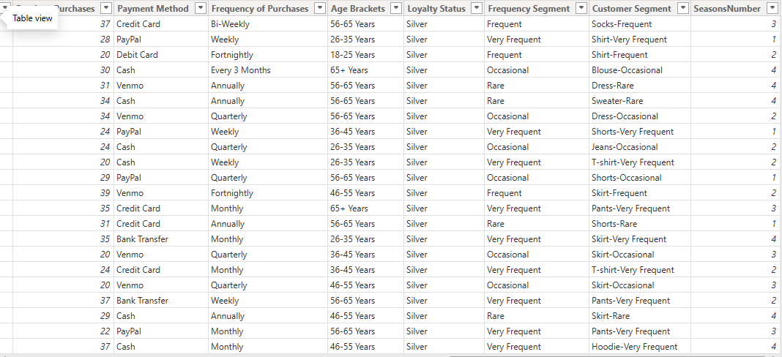

**Exploratory Analysis (Excel + Power BI):**

- Performed quick aggregations and initial charts in Excel to validate assumptions.  
- Moved prepared data into Power BI for richer visual analysis and cross-filtering exploration.  
  
**Dashboard Development in Power BI**

- Created two interactive dashboards (Sales Performance & Customer Shopping Behavior).  
- Used filters, slicers, and visuals to make the data more dynamic and accessible.  
  
**Use of DAX Measures**

DAX (Data Analysis Expressions) was used to create key calculations, including:  
- Total Sales = SUM(Sales[SalesAmount])

- Total Customers = DISTINCTCOUNT(Customer[CustomerID])

- Average Order Value (AOV) = DIVIDE([Total Sales], [Total Orders])

- Discount Usage % = DIVIDE([Customers with Discount], [Total Customers]) * 100

- Average Rating = AVERAGE(Customer[Rating])

- Age Grouping = Created calculated columns to segment customers into brackets (18–25, 26–35, etc.)

**These measures powered the KPIs and comparisons across gender, seasons, categories, and locations.**

**KPIs Monitored**

- Total Customers

- Total Sales

- Average Order Value

- Discount Usage %

- Average Age

- Average Customer Rating

**Sales Performance Insights**

**Highlights:**- Total Customers: 3,900

- Total Sales: $233K

- Avg. Order Value: $25.35

- Discount Usage: 43%

- Avg. Rating: 3.75

**Gender Contribution:**

- Male customers dominate with 67.74% (158K sales)

- Female customers: 32.26% (75K sales)

Top Items: Blouse, Shirt, Dress, Pants, Jewelry

Categories: Clothing leads (104K), Accessories (74K), Footwear (36K), Outerwear lowest (19K)

Seasons: Fall strongest (60K), Summer weakest (55.8K)

Location: Strong sales in populous US states

**Customer Shopping Behavior Insights**

- Avg. Age: 44 years

- Strongest contributors: 46–65 years

- Males shop more frequently than females

- Most common purchase cycle: every 3 months (584 customers)

- Subscription: 73% are active subscribers

- Discounts: 1.7K used, 2.2K didn’t — value beyond discounts matters

- Shipping: Free Shipping most popular, but fast options (Next Day, 2-Day) also widely used

**Business Implications**

1. **Prioritize Male Customers**
   * Men contribute over two-thirds of sales. Product development, promotions, and loyalty rewards should tilt toward male-driven categories.
2. **Grow Female Participation**
   * Women contribute less, but with targeted marketing (bundles, styling guides, and discounts), their engagement could be boosted.
3. **Address Seasonal Dips**
   * Launch campaigns or promotions in **Summer** to balance out the seasonal drop in sales.
4. **Leverage Loyalty**
   * With 73% of customers subscribing, adding perks like early access or exclusive discounts could strengthen retention further.
5. **Focus on Age 46–65**
   * This group is already loyal and high-spending. Tailored offers and personalized experiences will maximize their lifetime value.
6. **Shipping Flexibility is Key**
   * Maintain a balance between **free shipping** (value-driven customers) and **express shipping** (convenience-driven customers).

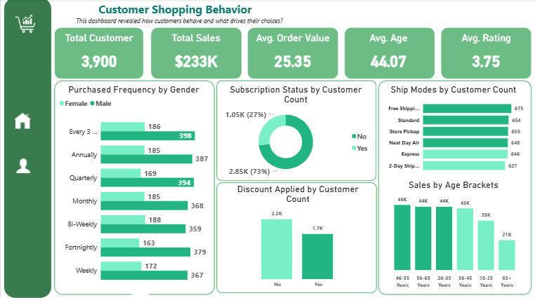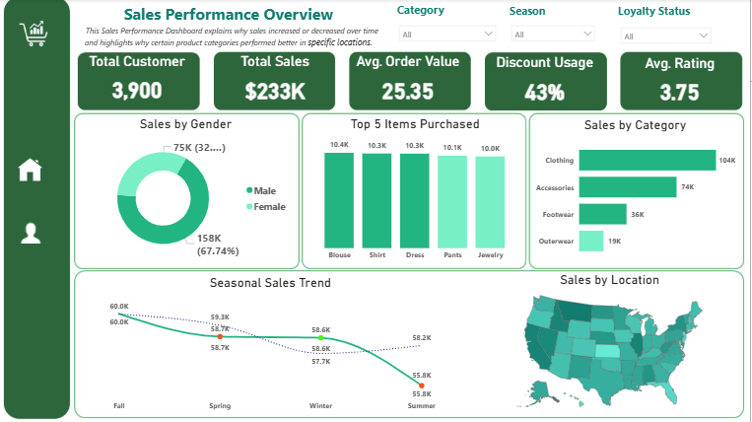

**Conclusion**

This analysis of the Shopping Behavior dataset goes beyond numbers and charts, it provides a window into customer lives and habits. The dashboards uncovered not just who the customers are, but also what drives their decisions, when they are most active, and how they prefer to interact with businesses.

**The findings are clear:**

* Male customers dominate total sales, making them the primary revenue drivers.
* Clothing and accessories remain the backbone of sales, while outerwear presents untapped potential.
* Middle-aged customers (46–65 years) form the strongest spending group, reinforcing their importance in long-term planning.
* Seasonal shifts shape demand, with Fall being the strongest and Summer the weakest.
* Loyalty and subscription adoption are high, providing businesses with an existing foundation to deepen engagement.

**For businesses, this means opportunity:**

* Doubling down on strategies for male shoppers while designing targeted campaigns to increase female engagement.
* Leveraging loyalty by enhancing subscription perks and delivering personalized experiences.
* Addressing seasonal dips with timely promotions and product launches.
* Investing in both affordable options (free shipping) and convenience (express delivery) to appeal to different customer needs.

Ultimately, the greatest lesson from this project is that understanding customer behavior is not just about boosting sales, it is about building relationships. When businesses listen to their customers, they move closer to being not just a store, but a trusted partner in their daily lives.

Businesses that listen to these insights move from simply selling to building long-lasting customer relationships.